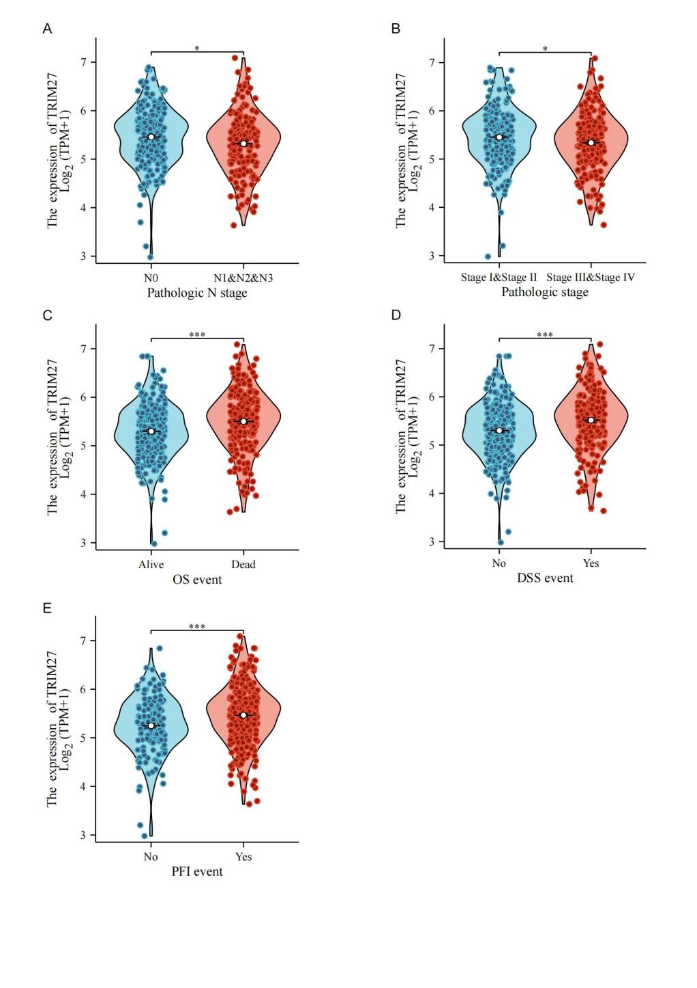
Supplementary Figure S1. Relationship between TRIM27 expression and clinicopathological parameters in Skin cutaneous melanoma. (A) Relationship between TRIM27 mRNA expression and tumor N stage. (B) Relationship between TRIM27 mRNA expression and pathological stage. (C) Relationship between TRIM27 mRNA expression and OS event. (D) Relationship between TRIM27 mRNA expression and DSS event. (E) Relationship between TRIM27 mRNA expression and PFI event. *P < 0.05, ***P < 0.001, P < 0.05 indicates statistical significance.
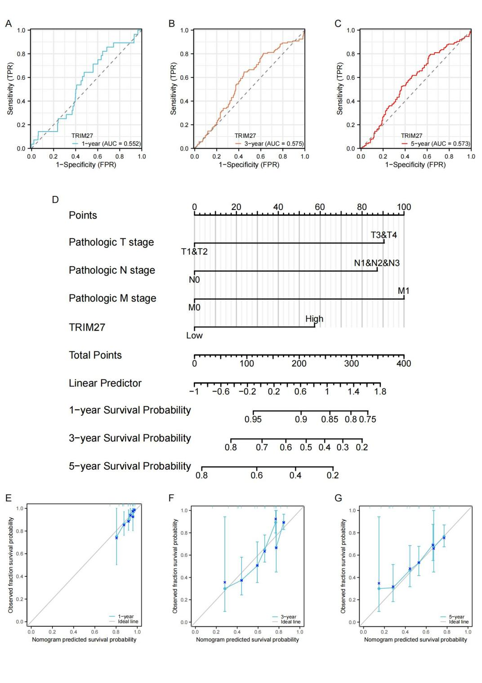
Supplementary Figure S2. Analysis of TRIM27 expression in the prognostic model. (A-C) Time-dependent ROC curves of TRIM27 for 1-year, 3-year, and 5-year. (D) Nomogram for predicting 1-year, 3-year, and 5-year OS of SKCM patients. (E-G) Calibration curves of the nomogram for predicting 1-year, 3-year, and 5-year OS of SKCM patients.

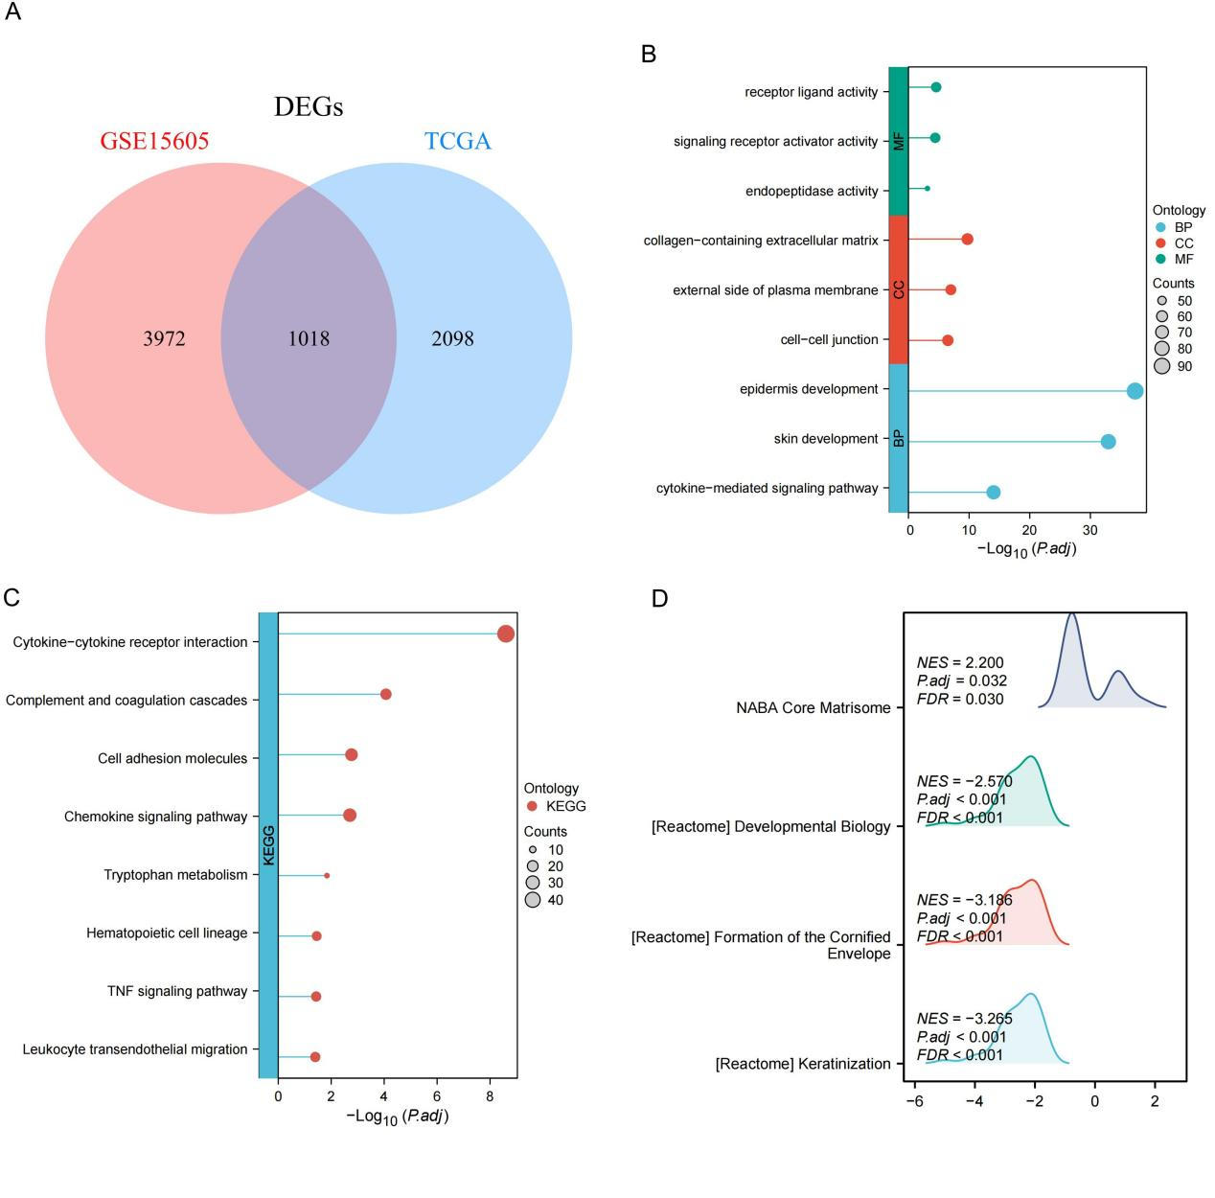

Supplementary Figure S3. Functional enrichment analysis of TRIM27. (A) Venn diagram showing the intersection of TRIM27-related differentially expressed genes (DEGs) in the TCGA database and the GSE15605 dataset. (B) GO analysis of TRIM27-related DEGs. (C) KEGG analysis of TRIM27-related DEGs. (D) GSEA analysis of TRIM27-related differentially expressed genes.

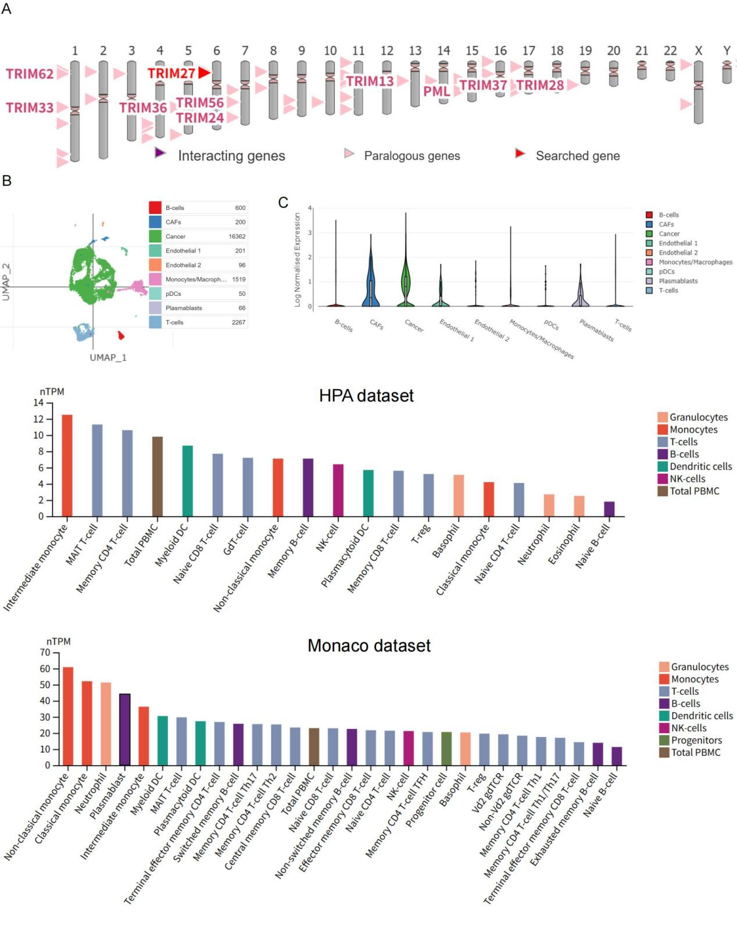
Supplementary Figure S4. Single-cell analysis of TRIM27 in Skin cutaneous melanoma. (A) The chromosomal location of TRIM27 and its interacting genes. (B) Distribution of various cell types in SKCM. (C) Expression of TRIM27 in various cell types of SKCM. (D) Expression of TRIM27 in immune cells from the HPA dataset. (E) Expression of TRIM27 in immune cells from the Monaco dataset.
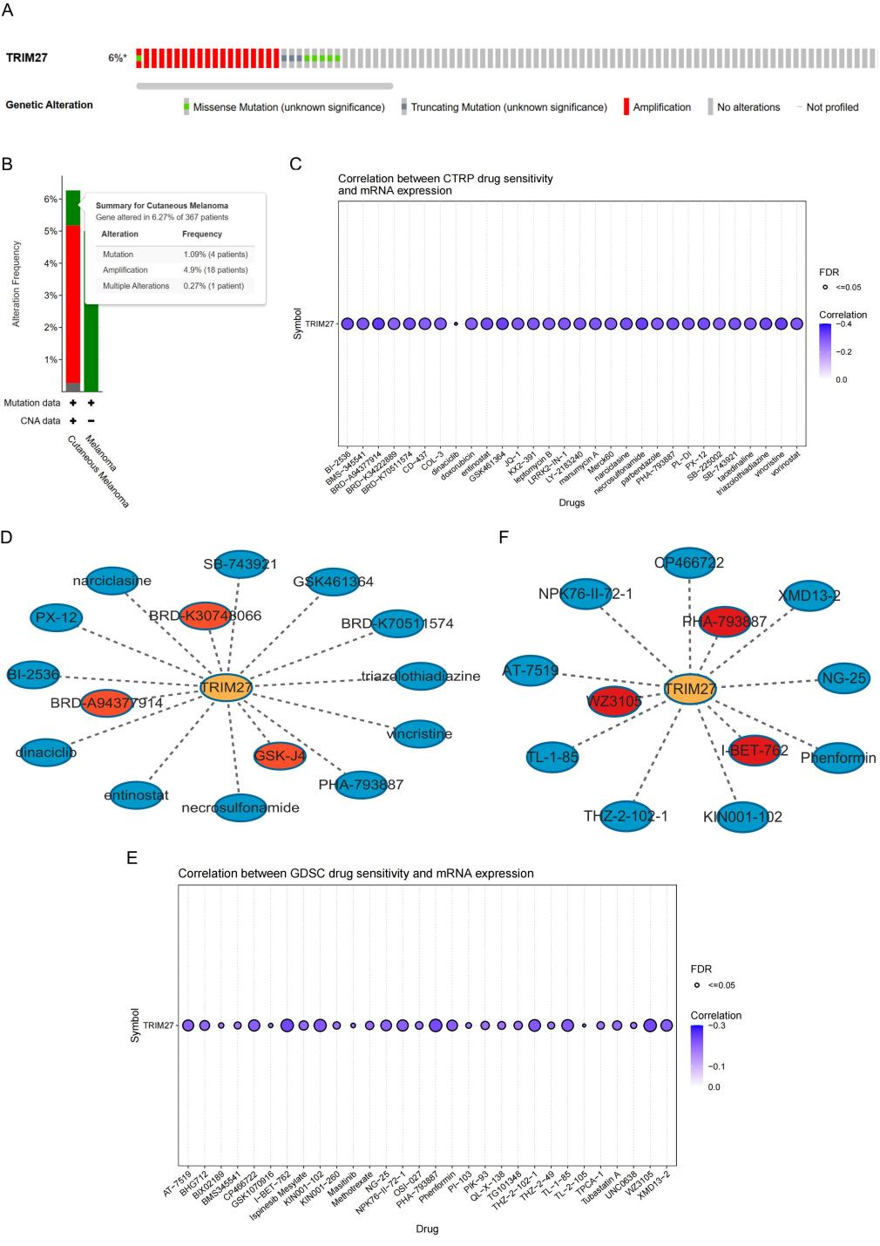
Supplementary Figure S5. Analysis of gene mutations and drug sensitivity of TRIM27. (A) Heatmap of types of TRIM27 gene mutations. (B) Types and frequencies of TRIM27 variations in SKCM. (C) Heatmap of the correlation between TRIM27 expression and drug sensitivity in the CTRP database. (D) Network diagram of TRIM27-related drugs in the CTRP database. (E) Heatmap of the correlation between TRIM27 expression and drug sensitivity in the GDSC database. (F) Network diagram of TRIM27-related drugs in the GDSC database.
Supplementary Table S2. Univariate and multifactorial analysis of clinicopathologic parameters in SKCM patients
Characteristics | Total (N) | Univariate analysis |  | Multivariate analysis
Characteristics | Total (N) | Hazard ratio (95% CI) | P value | Hazard ratio (95% CI) | P value
Pathologic T stage | 362
T1&T2 | 119 | Reference |  | Reference
T3&T4 | 243 | 2.099 (1.511–2.914) | < 0.001 | 1.985 (1.393 - 2.828) | < 0.001
Pathologic N stage | 403
N0 | 225 | Reference |  | Reference
N1&N2&N3 | 178 | 1.760 (1.310–2.365) | < 0.001 | 3.197 (1.134 - 9.014) | 0.028
Pathologic M stage | 431
M0 | 407 | Reference |  | Reference
M1 | 24 | 1.902 (1.032–3.506) | 0.039 | 2.420 (1.018 - 5.752) | 0.045
Pathologic stage | 411
Stage I&Stage II | 218 | Reference |  | Reference
Stage III&Stage IV | 193 | 1.625 (1.213–2.175) | 0.001 | 0.598 (0.209–1.710) | 0.337
Gender | 457
Female | 173 | Reference
Male | 284 | 1.180 (0.885–1.574) | 0.261
Age | 457
≤ 60 | 247 | Reference |  | Reference
> 60 | 210 | 1.663 (1.256–2.201) | < 0.001 | 1.171 (0.841–1.629) | 0.350
TRIM27 | 457
Low | 226 | Reference |  | Reference
High | 231 | 1.614 (1.228–2.122) | < 0.001 | 1.573 (1.139–2.173) | 0.006

