Supplementary materials

Supplementary Table S1. Incidence of specific cardiovascular outcomes by sex and earthquake exposure
Outcome | No Exposure | Incidence (%) | Exposure | Incidence (%)
Female (n = 3,501)
MI | 22 | 1.23 | 52 | 3.05
Stroke | 30 | 1.67 | 69 | 4.04
CAD | 40 | 2.23 | 95 | 5.57
HF | 25 | 1.39 | 48 | 2.81
AF | 28 | 1.56 | 46 | 2.70
Composite CVD | 117 | 6.52 | 247 | 14.48
Male (n = 3,911)
MI | 30 | 1.76 | 75 | 3.41
Stroke | 35 | 2.05 | 88 | 4.00
CAD | 50 | 2.93 | 128 | 5.81
HF | 28 | 1.64 | 60 | 2.73
AF | 32 | 1.87 | 65 | 2.95
Composite CVD | 120 | 7.02 | 308 | 13.99
Note. Sex-stratified distribution of incident cardiovascular outcomes among participants with and without earthquake exposure. Individual outcomes included myocardial infarction (MI), stroke, coronary artery disease (CAD), heart failure (HF), and atrial fibrillation (AF). Composite CVD represents the occurrence of at least one of these events during follow-up.

Supplementary Table S2. Sex-Specific baseline characteristics of the study population (female)
Characteristics  (Female) | Total (n = 3,501) | Earthquake |  | P-value
Characteristics  (Female) | Total (n = 3,501) | No (n = 1,795) | Yes (n = 1,706) | P-value
smoking, n (%) | 65 (1.85) | 31 (1.73) | 34 (1.99) | 0.866
drinking, n (%) | 86 (2.46) | 79 (4.40) | 7 (0.41) | < 0.001
age, Mean ± SD | 52.01 ± 8.99 | 52.22 ± 8.71 | 51.80 ± 9.28 | 0.164
sleep, Mean ± SD | 6.68 ± 1.35 | 6.69 ± 1.37 | 6.67 ± 1.32 | 0.603
education, n (%) |  |  |  | < 0.001
Illiteracy/Primary | 924 (26.39) | 217 (12.09) | 707 (41.44)
Middle school | 1,998 (57.07) | 1,065 (59.33) | 933 (54.69)
College or above | 579 (16.54) | 513 (28.58) | 66 (3.87)
hypertension, n (%) | 918 (26.22) | 364 (20.28) | 554 (32.47) | < 0.001
diabetes, n (%) | 254 (7.26) | 116 (6.46) | 138 (8.09) | 0.064
dyslipidemia, n (%) | 1,349 (38.53) | 584 (32.53) | 765 (44.84) | < 0.001
Note. SD = standard deviation.

Supplementary Table S3. Sex-Specific baseline characteristics of the study population (Male)
Characteristics  (Male) | Total (n = 3,911) | Earthquake |  | P-value
Characteristics  (Male) | Total (n = 3,911) | No (n = 1,709) | Yes (n = 2,022) | P-value
smoking, n (%) | 2,184 (55.84) | 976 (57.11) | 1,208 (54.86) | 0.160
drinking, n (%) | 951 (24.32) | 825 (48.27) | 126 (5.72) | < 0.001
age, Mean ± SD | 54.68 ± 10.72 | 53.47 ± 9.78 | 55.61 ± 11.31 | < 0.001
sleep, Mean ± SD | 6.67 ± 1.28 | 6.77 ± 1.33 | 6.57 ± 1.23 | < 0.001
education, n (%) |  |  |  | < 0.001
Illiteracy/Primary | 1,415 (36.18) | 198 (11.59) | 1,217 (60.19)
Middle school | 1,768 (45.21) | 891 (52.14) | 877 (43.37)
College or above | 728 (18.61) | 620 (36.28) | 108 (5.34)
hypertension, n (%) | 1,638 (41.88) | 493 (28.85) | 1,145 (52.00) | < 0.001
diabetes, n (%) | 452 (11.56) | 175 (10.24) | 277 (12.58) | 0.023
dyslipidemia, n (%) | 1,916 (48.99) | 807 (47.22) | 1,109 (50.36) | 0.051
Note. SD = standard deviation.

Supplementary Table S4. Baseline characteristics of participants according to earthquake exposure (after PSM)
Characteristics | Total (n = 3,468) | Earthquake  Yes (n = 1,734) | Earthquake  No (n = 1,734) | P
Age (years ± SD) | 52.36 ± 9.74 | 51.98 ± 9.06 | 52.73 ± 10.37 | 0.048
Sleep (hours ± SD) | 6.71 ± 1.32 | 6.71 ± 1.34 | 6.70 ± 1.30 | 0.758
Smoking, n (%) | 840 (24.22) | 417 (24.05) | 423 (24.39) | 0.812
Drinking, n (%) | 290 (8.36) | 158 (9.11) | 132 (7.61) | 0.111
Exercise, n (%) |  |  |  | < 0.001
Low intensity | 1,035 (29.85) | 513 (29.59) | 522 (30.10)
Modest intensity | 2,298 (66.26) | 1,178 (67.94) | 1,120 (64.59)
High intensity | 135 (3.89) | 43 (2.48) | 92 (5.31)
Income, n (%) |  |  |  | 0.488
< ¥3000 | 1,232 (35.52) | 617 (35.58) | 615 (35.47)
≥ ¥3000 | 2,236 (64.48) | 1,117 (64.42) | 1,119 (64.53)
Hypertension, n (%) | 1,045 (30.13) | 504 (29.07) | 541 (31.20) | 0.171
Diabetes, n (%) | 293 (8.45) | 144 (8.30) | 149 (8.59) | 0.760
Dyslipidemia, n (%) | 1,470 (42.39) | 730 (42.10) | 740 (42.68) | 0.731
Note. SD = standard deviation.

Supplementary Table S5. Association between earthquake experience and carotid atherosclerosis formation (after PSM)
Sex | Earth  quake | OR (95% CI)
Sex | Earth  quake | Unadjusted | P-value | Model 1 | P-value | Model 2 | P-value
Female | No | Ref |  | Ref |  | Ref
 | Yes | 2.91 (2.36–3.61) | < 0.001 | 2.23 (1.79–2.92) | 0.004 | 2.40 (1.98–2.92) | < 0.001
Male | No | Ref |  | Ref |  | Ref
 | Yes | 2.12 (1.68–2.67) | < 0.001 | 2.08 (1.59–2.73) | < 0.001 | 2.17 (1.64–2.88) | < 0.001
General population | No | Ref |  | Ref |  | Ref
 | Yes | 2.61 (2.25–3.04) | < 0.001 | 2.11 (1.75–2.54) | < 0.001 | 2.26 (1.71–2.81) | < 0.001
Note. Model 1 was adjusted for age, education and income. Model 2 was adjusted for age, education, income, hypertension, diabetes, dyslipidemia, drinking, smoking, and exercise. CI = confidence interval; OR = odds ratio; Ref = reference.

Supplementary Table S6. Association between earthquake exposure and high plaque burden (≥ 2 plaques)
Sex | Earthquake Exposure | Adjusted OR (95% CI) | P-value
Female | No | Ref
 | Yes | 1.63 (1.39–2.27) | < 0.001
Male | No | Ref
 | Yes | 1.24 (1.09–1.53) | < 0.001
General population | No | Ref
 | Yes | 1.32 (1.12–1.67) | < 0.001
Note. Adjusted for age, education, income, hypertension, diabetes, dyslipidemia, drinking, smoking, and exercise. CI = confidence interval; OR = odds ratio; Ref = reference.

Supplementary Table S7. CVD risk following earthquake exposure (after PSM)
Sex | Earth  quake | OR (95% CI)
Sex | Earth  quake | Unadjusted | P-value | Adjusted | P-value
Female | No | Ref |  | Ref
 | Yes | 1.91 (1.48–2.47) | < 0.001 | 1.66 (1.28–2.15) | < 0.001
Male | No | Ref |  | Ref
 | Yes | 1.12 (0.91–2.39) | 0.261 | 1.02 (0.82–1.13) | 0.637
Note. Adjusted for age, education, income, hypertension, diabetes, dyslipidemia, drinking, smoking, and exercise. CI = confidence interval; OR = odds ratio; Ref = reference.

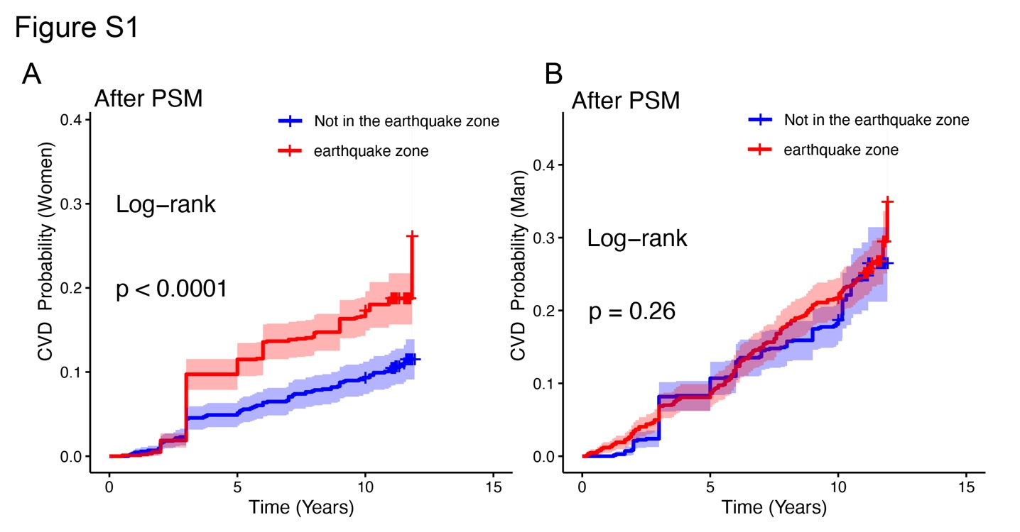
Supplementary Figure S1. Kaplan–Meier curve of cardiovascular disease risk by earthquake exposure (after PSM). The figure displays survival curves comparing the cumulative incidence of CVD events over time based on proximity to the earthquake epicenter.

