SUPPLEMENTARY MATERIALS

Supplementary Table S1. Countries matched with 185 countries from Globocan 2022
Health determinants | Not matched | Matched | Matched proportion (%)
Tobacco use | 29 | 156 | 84.3
Alcohol consumption | 10 | 175 | 94.6
Obesity | 6 | 179 | 96.8
Physical activity | 7 | 178 | 96.2
Marriage status | 5 | 180 | 97.3
Urban residence | 7 | 178 | 96.2
Maternal education | 5 | 180 | 97.3
Employment in in agriculture | 7 | 178 | 96.2
Lag distributed income | 7 | 178 | 96.2
Universal health coverage | 9 | 176 | 95.1
Health workforce | 7 | 178 | 96.2
Health expenditure | 14 | 171 | 92.4
Unsafe sanitation | 7 | 178 | 96.2
Note. 153 countries with full variables are enrolled in the final analysis.
Supplementary Table S2. Rationale for selection of the 15 health determinants
Health determinants | Epidemiological evidence | References
Personal innate characteristics
Gender | Sex is a key biological factor affecting the development of many cancer types. Compared to female patients, male patients are generally associated with higher mortality and worse survival times. | [1]
Age | Altered functioning of both telomerase and telomere-interacting proteins is present in some human premature ageing syndromes and in cancer. | [2]
Behavioral characteristics
Tobacco use | Smoking was significantly associated with increased disease incidence from 14 cancers, and with higher risks of death from lung cancer. | [3]
Alcohol consumption | Genotype-predicted alcohol intake was uniformly and positively associated with risks of death from pre-defined alcohol-related cancers (liver diseases, HR: 1.31; 95% confidence interval [CI]: 1.02–1.69). | [4]
Obesity | The most obese men and women had a 40–80% increased risk of dying from cancer. | [5]
Physical activity | Physical activity is inversely associated with and sedentary behaviour is positively (and independently) associated with an increased risk of more than ten types of cancer, including colorectal cancer (and advanced adenomas), endometrial cancers, and breast cancer. | [6]
Interpersonal network characteristics
Marriage status | For patients who have the cancers that contribute most to mortality, being unmarried is associated with worse overall survival compared with being married. | [7]
Urban residence | Most studies reported worse survival for cancer patients living in rural areas than those in urban regions. The most consistent evidence, observed across several studies, was for colorectal, lung, and prostate cancer. | [8]
Socio-economic characteristics
Maternal education | In comparison with the individuals with parents with the lowest level of education, the mortality rate ratios from all neoplasms was 0.92 (95% CI: 0.83–1.03) for those with parents with an intermediate level of education and 0.83 (95% CI: 0.72–0.95) for those with parents with the highest level of education. | [9]
Employment | Recognizing that health disparities do not exist in isolation but are part of a complex set of problems associated with education, housing, employment, health insurance, and community structures. | [10]
Lag distributed income | For cancer mortality, all other income groups showed significantly higher 3-year mortality rate ratios than the highest income group for males and females. | [11]
Macro-environmental characteristics
Universal health coverage | Universal health coverage (UHC) has protective effect on cancer mortality. Disparities in cancer outcomes between countries are probably a function of policies on coverage and allocation of health resources. | [12]
Health workforce | Considerable expansion of the world's health workforce is needed to achieve high levels of UHC effective coverage. | [13]
Health expenditure | Increases in public health-care expenditure as a percentage of gross domestic product were significantly associated with cancer mortality reductions. | [14]
Unsafe sanitation | Sustainable Development Goal (SDG) 6 proposed that by 2030, achieve access to adequate and equitable sanitation and hygiene for all and end open defecation, paying special attention to the needs of women and girls and those in vulnerable situations. Meeting the SDG equity agenda to “leave none behind” will require wash sanitation providers prioritize the hardest to reach including those living remotely and people who are disadvantaged. | [15]

References
[1] Zhu Y, Shao X, Wang X, et al. Sex disparities in cancer. Cancer Lett, 2019; 466, 35-8.
[2] Blasco MA. Telomeres and human disease: ageing, cancer and beyond. Nat Rev Genet, 2005; 6, 611-22.
[3] Chan KH, Wright N, Xiao D, et al. Tobacco smoking and risks of more than 470 diseases in China: a prospective cohort study. Lancet Public Health, 2022; 7, e1014-26.
[4] Millwood IY, Im PK, Bennett D, et al. Alcohol intake and cause-specific mortality: conventional and genetic evidence in a prospective cohort study of 512 000 adults in China. Lancet Public Health, 2023; 8, e956-67.
[5] Calle EE, Rodriguez C, Walker-Thurmond K, et al. Overweight, obesity, and mortality from cancer in a prospectively studied cohort of U.S. adults. N Engl J Med, 2003; 348, 1625-38.
[6] Kerr J, Anderson C, Lippman SM. Physical activity, sedentary behaviour, diet, and cancer: an update and emerging new evidence. Lancet Oncol, 2017; 18, e457-71.
[7] Martínez ME, Anderson K, Murphy JD, et al. Differences in marital status and mortality by race/ethnicity and nativity among California cancer patients. Cancer, 2016; 122, 1570-8.
[8] Afshar N, English DR, Milne RL. Rural-urban residence and cancer survival in high-income countries: A systematic review. Cancer, 2019; 125, 2172-84.
[9] Alicandro G, Bertuccio P, Sebastiani G, et al. Parental education and cancer mortality in children, adolescents, and young adults: A case-cohort study within the 2011 Italian census cohort. Cancer, 2020; 126, 4753-60.
[10] Odunsi K. Perspectives on Disparities and Equity in Cancer Outcomes: A Call to Action. Acad Med, 2023; 98, S54-9.
[11] Kim CW, Lee SY, Moon OR. Inequalities in cancer incidence and mortality across income groups and policy implications in South Korea. Public Health, 2008; 122, 229-36.
[12] Maruthappu M, Watkins J, Noor AM, et al. Economic downturns, universal health coverage, and cancer mortality in high-income and middle-income countries, 1990-2010: a longitudinal analysis. Lancet, 2016; 388, 684-95.
[13] GBD 2019 Human Resources for Health Collaborators. Measuring the availability of human resources for health and its relationship to universal health coverage for 204 countries and territories from 1990 to 2019: a systematic analysis for the Global Burden of Disease Study 2019. Lancet, 2022; 399, 2129-54.
[14] Colditz GA, Emmons KM. The role of universal health coverage in reducing cancer deaths and disparities. Lancet, 2016; 388, 638-40.
[15] GBD 2017 SDG Collaborators. Measuring progress from 1990 to 2017 and projecting attainment to 2030 of the health-related Sustainable Development Goals for 195 countries and territories: a systematic analysis for the Global Burden of Disease Study 2017. Lancet, 2018; 392, 2091-138.

Supplementary Table S3. Sensitivity analysis for the association between health determinants and all-cancer ASMR with mean years of schooling as an alternative indicator to maternal educational level
Health determinants | All ages |  |  | By age |  |  |  |  | By sex
Health determinants |  |  |  | <50 years (Early-onset) |  | 30–69 years  (Premature mortality) |  |  | Male |  | Female
Health determinants | OR (95% CI) | P value |  | OR (95% CI) | P value | OR (95% CI) | P value |  | OR (95% CI) | P value | OR (95% CI) | P value
Behavioral characteristics
Current tobacco use | 2.28  (1.58, 3.30) | < 0.01 |  | 1.04  (0.95, 1.16) | 0.40 | 4.33  (2.37, 7.91) | < 0.01 |  | 2.68  (1.89, 3.80) | < 0.01 | 1.63  (1.08, 2.47) | 0.02
Alcohol consumption | 5.53  (1.92, 15.93) | < 0.01 |  | 1.05  (0.79, 1.40) | 0.73 | 20.04  (3.58, 112.30) | < 0.01 |  | 8.77  (3.59, 21.47) | < 0.01 | 5.22  (0.51, 53.69) | 0.17
Obesity | 1.57  (1.07, 2.31) | 0.02 |  | 1.07  (0.97, 1.19) | 0.19 | 2.21  (1.19, 4.12) | 0.01 |  | 2.14  (1.23, 3.72) | 0.01 | 1.56  (1.14, 2.15) | 0.01
Low physical activity | 1.07  (0.67, 1.71) | 0.79 |  | 1.02  (0.90, 1.16) | 0.78 | 1.10  (0.51, 2.37) | 0.81 |  | 0.90  (0.41, 1.96) | 0.79 | 1.02  (0.72, 1.44) | 0.91
Interpersonal network characteristics
Married or in-union status for women aged 15–49 years | 0.62  (0.40, 0.95) | 0.03 |  | 0.89  (0.79, 1.00) | 0.05 | 0.67  (0.33, 1.36) | 0.27 |  | 0.63  (0.35, 1.15) | 0.13 | 0.61  (0.41, 0.91) | 0.02
Urban residence | 1.06  (0.84, 1.35) | 0.61 |  | 1.02  (0.95, 1.08) | 0.63 | 0.96  (0.65,1.40) | 0.82 |  | 1.00  (0.73, 1.38) | 0.99 | 1.08  (0.87, 1.35) | 0.49
Socio-economic characteristics
Mean years of schooling | 4.10  (0.45, 37.30) | 0.21 |  | 0.89  (0.49, 1.61) | 0.69 | 10.57  (0.29, 384.80) | 0.20 |  | 7.35  (0.35, 154.00) | 0.20 | 3.57  (0.55, 23.31) | 0.19
Employment status in agriculture | 1.53  (1.11, 2.11) | 0.01 |  | 1.13  (1.04, 1.24) | 0.01 | 1.87  (1.11, 3.16) | 0.02 |  | 1.49  (0.92, 2.41) | 0.11 | 1.26  (1.01, 1.58) | 0.05
Lag distributed income | 1.00  (1.00, 1.00) | 0.02 |  | 1.00  (1.00, 1.00) | 0.03 | 1.00  (1.00, 1.00) | 0.01 |  | 1.00  (1.00, 1.00) | 0.01 | 1.00  (1.00, 1.00) | 0.24
Macro-environmental characteristics
Health expenditure | 0.32  (0.10, 1.09) | 0.07 |  | 0.87  (0.62, 1.21) | 0.40 | 0.18  (0.03, 1.33) | 0.10 |  | 0.25  (0.05, 1.33) | 0.11 | 0.40  (0.13, 1.26) | 0.12
UHC index | 1.24  (0.74, 2.07) | 0.41 |  | 1.01  (0.88, 1.16) | 0.87 | 1.02  (0.44,2.34) | 0.97 |  | 1.74  (0.88, 3.45) | 0.11 | 0.80  (0.49, 1.30) | 0.36
Health workforce | 1.03  (0.98, 1.07) | 0.24 |  | 1.00  (0.98, 1.01) | 0.53 | 1.01  (0.94, 1.08) | 0.84 |  | 1.03  (0.97, 1.09) | 0.39 | 1.03  (0.98, 1.07) | 0.24
Unsafe sanitation | 1.09  (0.82, 1.44) | 0.55 |  | 1.08  (1.00, 1.16) | 0.06 | 1.16  (0.73, 1.83) | 0.53 |  | 1.05  (0.71, 1.55) | 0.81 | 1.26  (0.97, 1.65) | 0.09
Note. Definition of abbreviations: ASMR, age-standardized mortality rate; OR, odds ratio; CI, confidence interval; UHC,universal health coverage. The multivariable model was reconstructed using mean years of schooling obtained from Our World in Data as an alternative indicator to maternal educational level.
Supplementary Table S4. Sensitivity analysis for the association between health determinants and all-cancer ASMR further adjusted for ambient particulate matter pollution
Health determinants | All ages |  | By age |  |  |  |  | By sex
Health determinants |  |  | < 50 years (Early-onset) |  | 30–69 years  (Premature mortality) |  |  | Male |  | Female
Health determinants | OR (95% CI) | P value | OR (95% CI) | P value | OR (95% CI) | P value |  | OR (95% CI) | P value | OR (95% CI) | P value
Behavioral characteristics
Current tobacco use | 2.20  (1.52, 3.20) | < 0.01 | 1.02  (0.93, 1.13) | 0.65 | 4.08  (2.21, 7.51) | < 0.01 |  | 2.53  (1.76, 3.62) | < 0.01 | 1.49  (1.00, 2.23) | 0.05
Alcohol consumption | 4.37  (1.46, 13.09) | 0.01 | 0.99  (0.73, 1.33) | 0.94 | 14.56  (2.43, 87.42) | < 0.01 |  | 7.99  (3.08, 20.74) | < 0.01 | 3.10  (0.29, 32.64) | 0.35
Obesity | 1.65  (1.13, 2.41) | 0.01 | 1.07  (0.96, 1.18) | 0.23 | 2.30  (1.24, 4.27) | 0.01 |  | 2.17  (1.24, 3.81) | 0.01 | 1.63  (1.19, 2.22) | < 0.01
Low physical activity | 1.10  (0.69, 1.75) | 0.70 | 1.04  (0.91, 1.18) | 0.60 | 1.12  (0.52, 2.41) | 0.77 |  | 0.81  (0.37, 1.77) | 0.60 | 1.06  (0.75, 1.49) | 0.75
Interpersonal network characteristics
Married or in-union status for women aged 15–49 years | 0.67  (0.43, 1.03) | 0.07 | 0.91  (0.80, 1.02) | 0.10 | 0.74  (0.36, 1.52) | 0.42 |  | 0.69  (0.37, 1.27) | 0.23 | 0.67  (0.45, 1.00) | 0.05
Urban residence | 1.03  (0.81, 1.31) | 0.81 | 1.01  (0.95, 1.08) | 0.74 | 0.91  (0.62, 1.33) | 0.62 |  | 1.00  (0.72, 1.39) | 0.99 | 1.04  (0.83, 1.30) | 0.72
Socio-economic characteristics
Maternal educational level | 6.16  (0.63, 60.27) | 0.12 | 1.26  (0.68, 2.34) | 0.47 | 22.79  (0.55, 944.60) | 0.10 |  | 5.35  (0.21, 136.40) | 0.31 | 8.03  (1.10, 58.74) | 0.04
Employment status in agriculture | 1.55  (1.12, 2.13) | 0.01 | 1.14  (1.04, 1.24) | 0.01 | 1.92  (1.14, 3.23) | 0.02 |  | 1.47  (0.91, 2.39) | 0.12 | 1.29  (1.03, 1.61) | 0.03
Lag distributed income | 1.00  (1.00, 1.00) | 0.04 | 1.00  (1.00, 1.00) | 0.07 | 1.00  (1.00, 1.00) | 0.02 |  | 1.00  (1.00, 1.00) | 0.02 | 1.00  (1.00, 1.00) | 0.53
Macro-environmental characteristics
Health expenditure | 0.29  (0.09, 1.00) | 0.05 | 0.88  (0.63, 1.22) | 0.44 | 0.17 (0.02 ,1.28) | 0.09 |  | 0.25  (0.05, 1.35) | 0.11 | 0.38  (0.12, 1.18) | 0.10
UHC index | 1.29  (0.77, 2.18) | 0.34 | 1.00  (0.87, 1.16) | 0.96 | 1.03  (0.44, 2.42) | 0.94 |  | 1.75  (0.86, 3.59) | 0.13 | 0.83  (0.51, 1.35) | 0.46
Health workforce | 1.02  (0.97, 1.06) | 0.50 | 0.99  (0.98, 1.00) | 0.21 | 1.00  (0.92, 1.07) | 0.92 |  | 1.02  (0.96, 1.09) | 0.56 | 1.01  (0.97, 1.05) | 0.66
Unsafe sanitation | 1.06  (0.80, 1.40) | 0.68 | 1.08  (1.00, 1.16) | 0.06 | 1.12  (0.71, 1.76) | 0.63 |  | 0.97  (0.66, 1.43) | 0.89 | 1.21  (0.93, 1.56) | 0.16
Note. Definition of abbreviations: ASMR, age-standardized mortality rate; OR, odds ratio; CI, confidence interval; UHC,universal health coverage.

Supplementary Table S5. Association between health determinants and ASIR for all cancers
Health determinants | Total |  |  | By age |  |  |  |  | By sex
Health determinants |  |  |  | < 50 years (Early-onset) |  | 30–69 years  (Premature mortality) |  |  | Male |  | Female
Health determinants | OR (95% CI) | P value |  | OR (95% CI) | P value | OR (95% CI) | P value |  | OR (95% CI) | P value | OR (95% CI) | P value
Behavioral characteristics
Current tobacco use | 5.44  (2.42, 12.23) | <0.01 |  | 1.51  (1.15, 1.98) | <0.01 | 24.43  (5.76, 103.70) | < 0.01 |  | 3.23  (1.61, 6.47) | < 0.01 | 5.41  (2.34, 12.52) | <0.01
Alcohol consumption | 824.90  (80.19, 8486.00) | <0.01 |  | 4.19  (1.93, 9.08) | <0.01 | 191000.00 (3000.00, 12200000.00) | < 0.01 |  | 419.10  (69.66, 2521.00) | < 0.01 | 9413.00  (71.22, 1240000.00) | <0.01
Obesity | 1.83  (0.81, 4.16) | 0.15 |  | 1.07  (0.82, 1.41) | 0.61 | 2.70  (0.63, 11.61) | 0.19 |  | 4.31  (1.46, 12.67) | 0.01 | 1.44  (0.75, 2.75) | 0.27
Low physical activity | 2.16  (0.79, 5.93) | 0.14 |  | 1.41  (1.01, 1.98) | 0.05 | 5.76  (0.95, 34.79) | 0.06 |  | 1.67  (0.38, 7.34) | 0.50 | 1.65  (0.81, 3.37) | 0.17
Interpersonal network characteristics
Married or in-union for women aged 15–49 years | 0.43  (0.17, 1.10) | 0.08 |  | 0.78  (0.57, 1.06) | 0.12 | 0.36  (0.07, 1.92) | 0.23 |  | 0.42  (0.13, 1.35) | 0.15 | 0.60  (0.26, 1.38) | 0.23
Urban residence | 1.93  (1.15, 3.23) | 0.01 |  | 1.30  (1.09, 1.54) | <0.01 | 2.88  (1.15, 7.21) | 0.03 |  | 1.75  (0.93, 3.29) | 0.08 | 2.07  (1.29, 3.31) | <0.01
Socio-economic characteristics
Maternal educational level | 0.30  (0.00, 38.91) | 0.63 |  | 0.63  (0.13, 3.16) | 0.58 | 0.21  (0.00, 1229.00) | 0.73 |  | 0.31  (0.00, 144.70) | 0.71 | 2.62  (0.04, 158.70) | 0.65
Employment in agriculture | 1.39  (0.70, 2.79) | 0.35 |  | 1.14 (0.90,1.43) | 0.28 | 1.40  (0.41, 4.83) | 0.60 |  | 1.39  (0.55, 3.55) | 0.49 | 1.12  (0.70, 1.80) | 0.63
Lag distributed income | 1.00  (1.00, 1.00) | 0.02 |  | 1.00  (1.00, 1.00) | 0.02 | 1.00  (1.00, 1.00) | <0.01 |  | 1.00  (1.00, 1.00) | 0.01 | 1.00  (1.00, 1.00) | 0.23
Macro-environmental characteristics
Health expenditure | 1.06  (0.07, 15.02) | 0.97 |  | 1.05  (0.43, 2.54) | 0.92 | 0.63  (0.01,71.42) | 0.85 |  | 1.65  (0.06, 42.64) | 0.77 | 0.81  (0.07, 8.81) | 0.86
UHC index | 1.35  (0.44, 4.13) | 0.60 |  | 1.12  (0.77, 1.62) | 0.56 | 1.19  (0.16, 8.73) | 0.87 |  | 1.64  (0.42, 6.44) | 0.48 | 0.85  (0.31, 2.32) | 0.75
Health workforce | 1.40  (1.28, 1.53) | < 0.01 |  | 1.07  (1.03 , 1.10) | < 0.01 | 1.73  (1.47, 2.04) | < 0.01 |  | 1.46  (1.30, 1.63) | < 0.01 | 1.29  (1.19, 1.40) | < 0.01
Unsafe sanitation | 1.02  (0.56, 1.87) | 0.95 |  | 1.05  (0.86, 1.29) | 0.62 | 1.08  (0.37, 3.17) | 0.89 |  | 0.92  (0.44, 1.94) | 0.83 | 1.21  (0.70, 2.08) | 0.49
Note. Definition of abbreviations: ASIR, age-standardized incidence rate; OR, odds ratio; CI, confidence interval.

Supplementary Table S6. Proportion of cancer death attributable to modifiable risk factors at the global level, 2023
Cause | Population attributable fraction (%)
Total cancers
Residential radon | 0.8 (-0.4, 2.0)
Smoking | 19.4 (16.6, 22.6)
Secondhand smoke | 2.0 (1.6, 2.4)
Diet low in fruits | 0.9 (0.4, 1.4)
Diet low in vegetables | 0.8 (-0.1, 1.6)
Diet low in whole grains | 1.8 (0.8, 2.6)
Diet low in milk | 1.5 (0.5, 2.4)
Diet high in red meat | 2.3 (0.0, 4.9)
Diet high in processed meat | 0.6 (0.2, 0.9)
Diet low in fiber | 0.1 (0.0, 0.2)
Diet high in sodium | 0.7 (0.0, 3.6)
Occupational carcinogens | 3.2 (2.6, 3.8)
Diet low in calcium | 0.8 (0.6, 1.0)
Chewing tobacco | 0.9 (0.6, 1.4)
Particulate matter pollution | 3.3 (2.2, 4.5)
Tracheal, bronchus, and lung cancer
Residential radon | 4.1 (-1.8, 10.2)
Smoking | 58.3 (53.4, 62.7)
Secondhand smoke | 7.9 (6.3, 9.5)
Diet low in fruits | 4.4 (2.2, 6.9)
Occupational carcinogens | 14.3 (11.4, 17.4)
Particulate matter pollution | 17.1 (11.6, 22.7)
Colon and rectum cancer
Smoking | 4.3 (2.7, 6.3)
Diet low in whole grains | 16.7 (7.4, 24.9)
Diet low in milk | 15.2 (4.1, 25.1)
Diet high in red meat | 14.2 (0.0, 28.7)
Diet high in processed meat | 5.4 (1.9, 9.0)
Diet low in fiber | 0.9 (0.3, 2.0)
Diet low in calcium | 7.7 (5.6, 10.0)
Breast cancer
Smoking | 1.3 (0.9, 1.7)
Secondhand smoke | 5.7 (3.6, 8.0)
Diet high in red meat | 11.1 (0.0, 24.3)
Esophageal cancer
Smoking | 35.4 (28.6, 42.6)
Diet low in vegetables | 13.8 (-2.5, 28.9)
Chewing tobacco | 4.9 (3.1, 7.5)
Prostate cancer
Smoking | 3.1 (1.4, 5.2)
Diet low in milk | -2.5 (-7.0, 1.8)
Diet low in calcium | -1.0 (-2.1, 0.2)
Larynx cancer
Smoking | 64.9 (58.5, 70.1)
Occupational carcinogens | 5.9 (3.7, 8.4)
Chewing tobacco | 10.2 (5.6, 15.4)
Nasopharynx cancer
Smoking | 17.5 (13.4, 22.9)
Occupational carcinogens | 0.8 (0.6, 1.1)
Chewing tobacco | 6.2 (3.3, 10.1)
Note. Data are obtained from the Global Burden of Disease Study 2023.
- All ages (B) By age
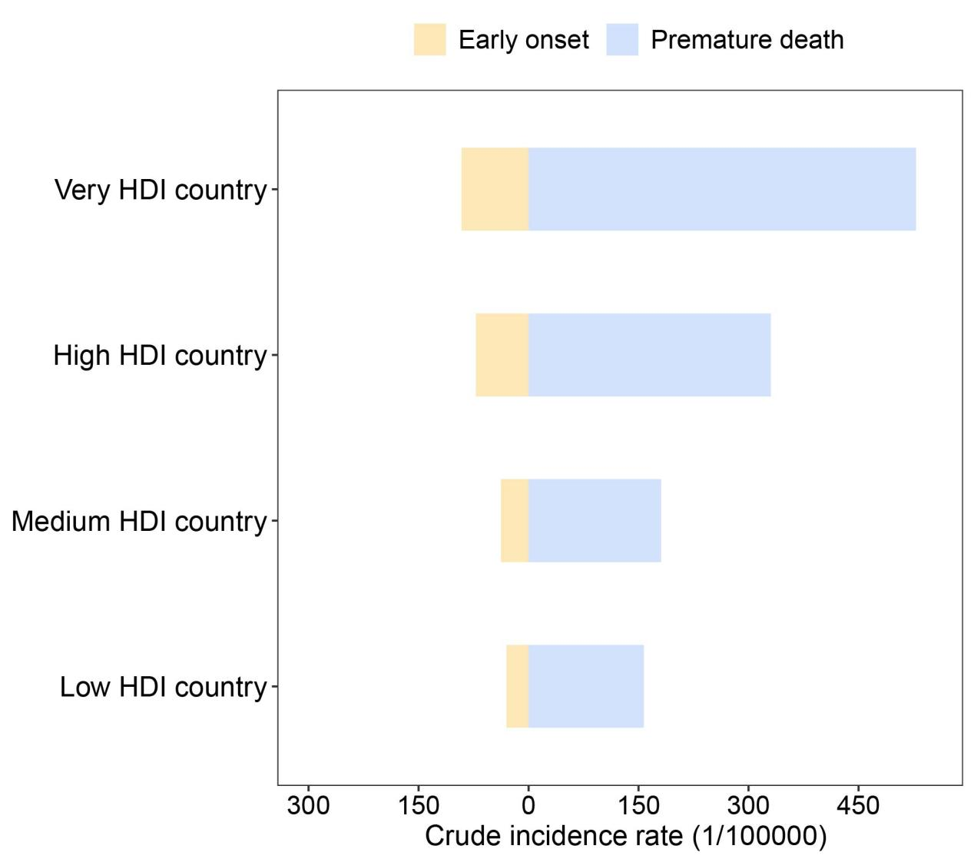

(C) By sex
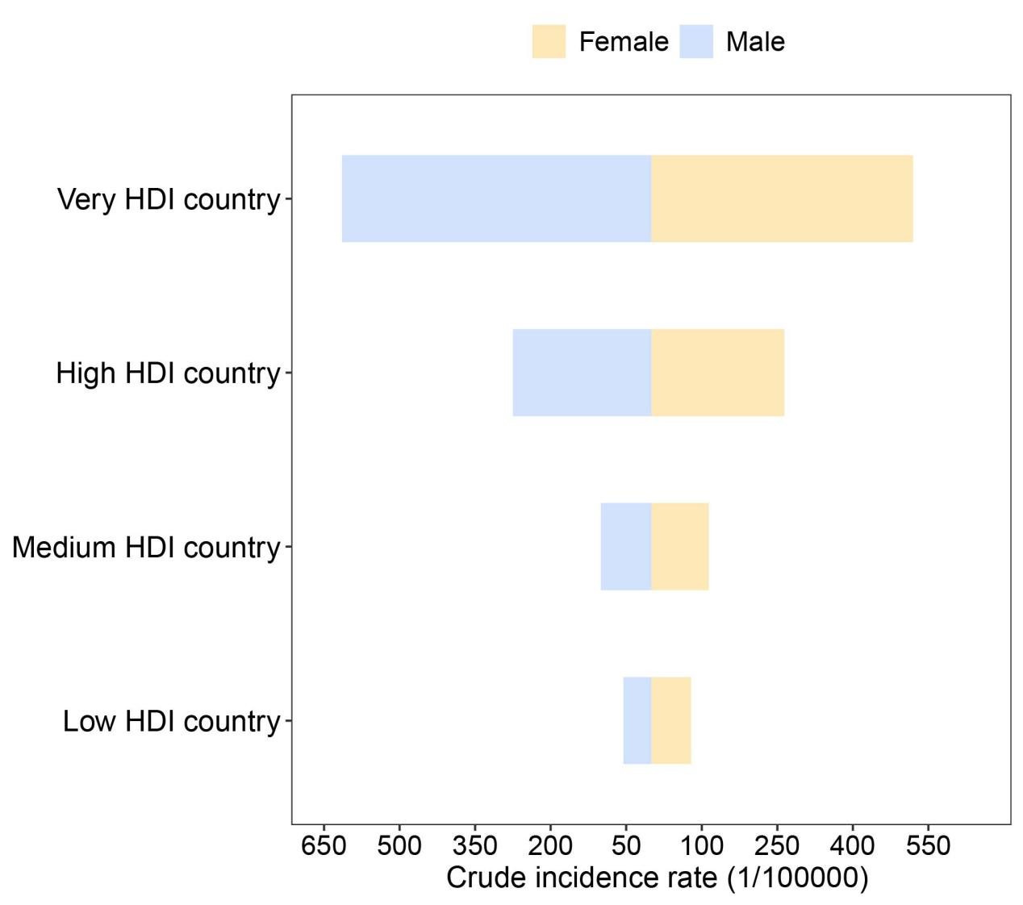
Supplementary Figure S1. Crude incidence rate for all cancers in 2022.

